DRAWING I

teacher: Mrs. Rachel Applegate email: rapplegate@ccs.us

Course Description:
This class is designed for students interested in further engagement in visual art practices and critical thinking. Students will be exposed to various drawing techniques and media over the course of the semester. A study of art history, art criticism, and aesthetics is imbedded in the class curriculum. Students will explore the elements and principles of art, through experimentation/art making but more importantly will learn to problem solve, evaluate, critique, and think like an artist through enduring concepts/themes.

Welcome and I look forward to a great semester!

Assignments/Grading:
There will be about four projects through the course of the semester. Any practice work, worksheets, or other supplemental activities related to each project will be factored into the individual project grade. Some independent research/homework may be necessary.

Weekly sketchbook assignments will be given and students are required to bring their sketchbook to class every day. Sketchbook/visual journals are an integral part of an artist’s life and are used for a variety of purposes: to record and sketch ideas; to reflect on thoughts; to take notes on artists/artwork, art making processes, vocabulary/terms.

Grades will be composed of daily PREP (preparation, respect, effort, participation) points, sketchbook, and projects. A rubric/criteria breakdown for every project will be explained and distributed.

If you turn in work late you will lose points per day. If you are working hard you might be eligible for a work extension – You will need to see me and discuss it before the due date!

Materials:
While CCS supplies most materials students will need, students will be required to provide a few items for themselves.

- 9”X12” blank paper sketchbook (no lined paper)
- HIGHLY RECCOMENDED: Drawing pencils 6H, 4H, 2H, HB, 2B, 4B, 6B, White “Magic Rub” Eraser, Kneaded eraser, Fine tipped black Sharpie, Small case or baggie to hold supplies

Art Studio Expectations

- We are responsible…for our words and actions.
- Come to class on time and prepared (seated quietly, sketchbook and pencil out/ready). Make sure you have a pass if you are late.
- Your actions affect others and vice versa.
- Participate!
- Make sure your artwork is school appropriate.

- We are respectful…to ourselves, to each other, with our materials, and our studio space.
- Think before speaking: be kind, be helpful.
- Clean up after yourself- this is a shared space.
- Be quiet and listen during demonstrations, presentations, etc.

- We are reflective…we take time to listen, ask, and revise. We learn and grow from our choices.
- Share ideas!
- Take risks!

Our art studio is a safe community of mutual support and trust that is open to all learners and seekers, in which we act respectfully, responsibly, and reflectively.

If you ever have questions/concerns, please see me or email me at rapplegate@ccs.us
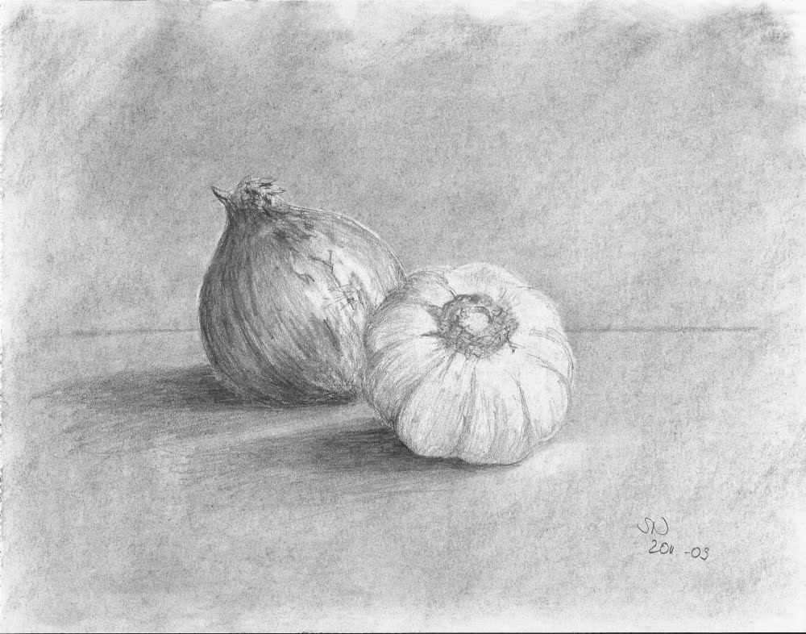

“He who works with his hands is a laborer.
He who works with his hands and his head is a craftsman.
He who works with his hands and his head and his heart is an artist.”
― Francis of Assisi

